IBM Data Science Capstone Project

Finding the location of a close French Restaurant close to Conrad Hotel.

**Introduction/Problem**

I got a scholarship New York University to study predictive analysis, so got the nearest flight to New York and lodge at an Hotel, Conrad New York city hotel to be precise. So at lunch time i desire to have a French meal, and the hotel could not deliver such, so i had to look for the nearest restaurant on French meal close to the hotel i lodged in for the day.

So the problem is which French restaurant is available very close to the hotel, and is there a possibility to start a business on French meal restaurant

**2. Data**

**2.1 Description of Data**

This project will rely on public data from Wikipedia and Foursquare.

**2.1.1 Dataset 1:**

In this project, New York will be the city to focus on in this project. Within the New York Area project, The focus of this project will be the nieghbourhoods that are within the New York area.

The New York Area consists of 5 Boroughs. Our data will be from the link - Greater London Area <https://en.wikipedia.org/wiki/List_of_cities_in_New_York_(state)>

The libraries imported are as follows:

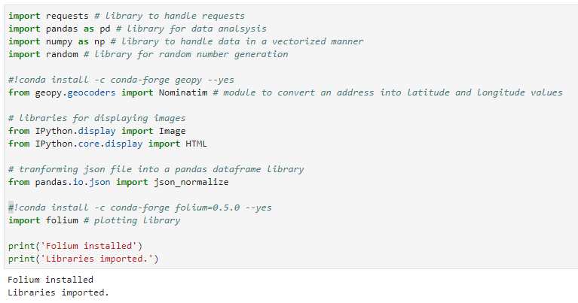

The following libraries are imported and in front of each imported and downloaded libraries shows the function of each libraries.

So, to get a location or work on a location project in python, you need to work with an API organization, we have quite few of them but the one I used here is the quite popular organization which is the Foursquare API code.

So, I had to visit foursquare.com to register and also get a CLIENT_ID & CLIENT_SECRET, everyone should have a personal code. So I put in my API credentials, in other to be able to access the data provided at foursquare:

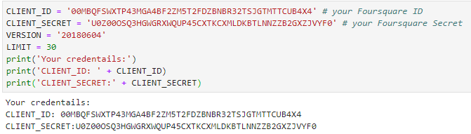

Next, is to get the longitude ad latitude of the hotel I lodged in:

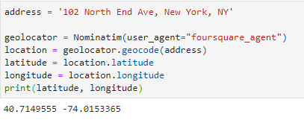

Which means for Conrad Hotel has latitude of 40.7149555 and longitude of -74.0153365

Next, I want to get any location of French of radius 1000 around my hotel, the result brought out 8 locations with two of them being French restaurant.

1. M C Choi French Restaurant with distance of 751m from the hotel
2. Frenchette with distance of 957m to the hotel

So, with mere looking, M C Choi restaurant should be close and quick but foursquare API code help us in checking rate, reviews and comment about any location. So let’s check the rate to know which restaurant to go.

And also we have the map showing all French locations close to the hotel, the hotel in red label, while all French locations in blue labels.

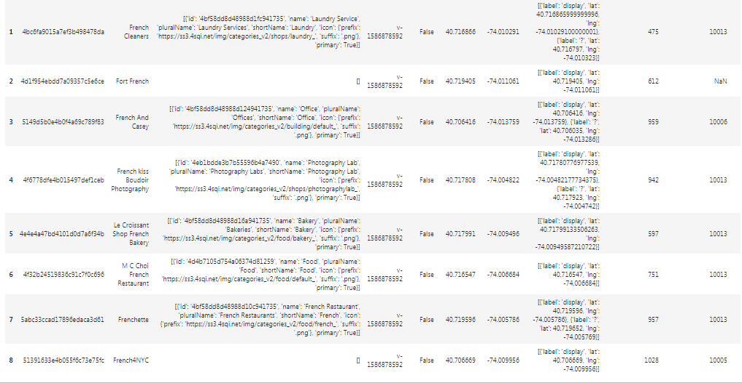

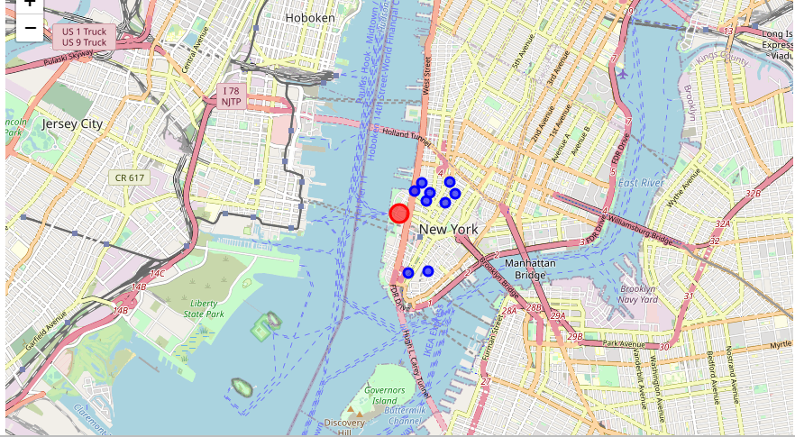

So, exploring M C Choi restaurant, the result shows that the restaurant shows that the venue hasn’t been rated yet. Which is not a good sign of quality

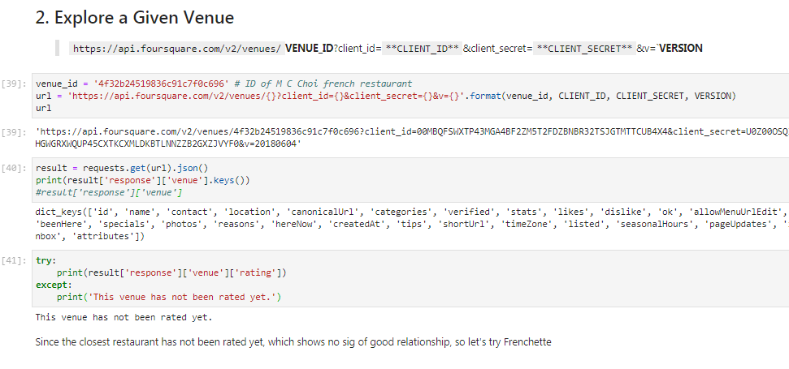

So, let’s try Frenchette,

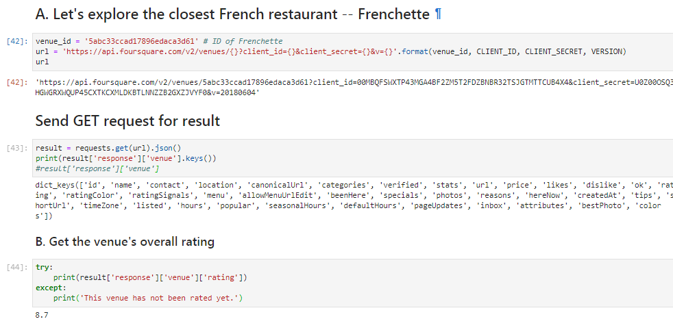

We can see that the restaurant has been rated 8.7/10, which serve as a sign of good quality, and there were some comments/reviews about the restaurant.

The Restaurant had 34 tips from people:

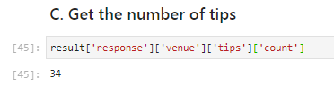

And one of the comment from the reviewer is pasted below:

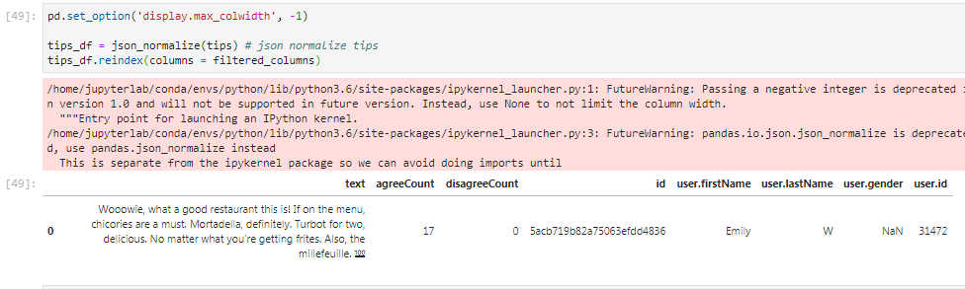

### Hence Frenchette serve as a good restaurant close to the hotel i lodged in, and there's a problem of distance from the hotel, which serve as a research for a business man to start a French restaurant which will be close to the hotel location, since the hotel has no French meal on the table.